**AIM: Array and User defined functions Programs**

**1. Write a program to remove duplicate elements of an array.**

using System;

using System.Collections.Generic;

using System.Linq;

using System.Text;

using System.Threading.Tasks;

using static System.Net.Mime.MediaTypeNames;

namespace Practical_3

{

internal class Practical_3_1_

{

static void Main(string[] args)

{

Console.WriteLine("By : 21012021003_AMIT GOSWAMI\n");

int i, j, k, n;

Console.Write("Please enter size of array : ");

n = Convert.ToInt32(Console.ReadLine());

int[] arr = new int[n];

Console.WriteLine("Enter the values you want to enter in array :");

for (i = 0; i < n; i++)

{

arr[i] = Convert.ToInt32(Console.ReadLine());

}

for (i = 0; i < n; i++)

{

for (j = i + 1; j < n; j++)

{

if (arr[i] == arr[j])

{

for (k = j; k < n - 1; k++)

{

arr[k] = arr[k + 1];

}

n--;

}

}

}

Console.WriteLine("Printing the array with unique elements :");

for (i = 0; i < n; i++)

{

Console.Write(arr[i] + " ");

}

Console.ReadKey();

}

}

}

**Output:**

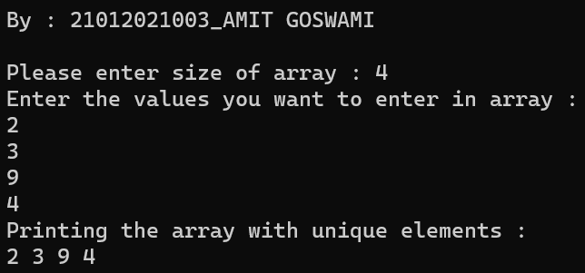

1. **Write a program for multiplication of two 2-dimensional matrices using 2-d array.**

**Program:**

using System;

using System.Collections.Generic;

using System.Linq;

using System.Text;

using System.Threading.Tasks;

using static System.Net.Mime.MediaTypeNames;

namespace Practical_3

{

internal class Practical_3_2_

{

static void Main(string[] args)

{

Console.WriteLine("By : 21012021003_AMIT GOSWAMI \n");

int[,] a = new int[3, 3];

int[,] b = new int[3, 3];

int[,] c = new int[3, 3];

int i, j, k;

Console.WriteLine("Enter values of matrix A :");

for (i = 0; i < 3; i++)

{

for (j = 0; j < 3; j++)

{

a[i, j] = Convert.ToInt32(Console.ReadLine());

}

}

Console.WriteLine("Enter values of matrix B :");

for (i = 0; i < 3; i++)

{

for (j = 0; j < 3; j++)

{

b[i, j] = Convert.ToInt32(Console.ReadLine());

}

}

for (i = 0; i < 3; i++)

{

for (j = 0; j < 3; j++)

{

c[i, j] = 0;

for (k = 0; k < 3; k++)

{

c[i, j] += a[i, k] * b[k, j];

}

}

}

Console.WriteLine("values of matrix C (by mul of A and B):");

for (i = 0; i < 3; i++)

{

for (j = 0; j < 3; j++)

{

Console.Write("{0}\t", c[i, j]);

}

Console.Write("\n");

}

Console.ReadKey();

}

}

}

Output:

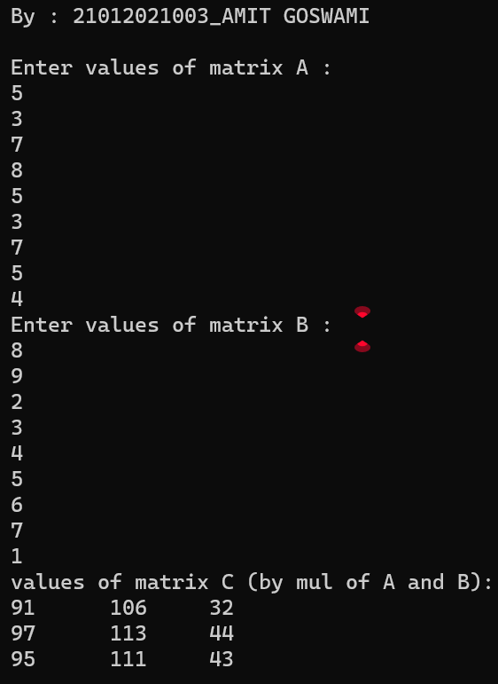

1. **Write a program to generate Pascal Triangle using jagged array.**

**Program:**

using System;

using System.Collections.Generic;

using System.Linq;

using System.Text;

using System.Threading.Tasks;

using static System.Net.Mime.MediaTypeNames;

namespace Practical_3

{

internal class Practical_3_3_

{

static void Main(string[] args)

{

Console.WriteLine("By : 21012021003_AMIT GOSWAMI \n");

int[][] a = new int[6][];

int i, j;

for (i = 0; i<a.Length; i++)

{

a[i] = new int[i + 1];

}

for (i = 0; i<a.Length; i++)

{

for (j = 0; j<a[i].Length; j++)

{

if (j == 0 || i == j)

{

a[i][j] = 1;

}

else

{

a[i][j] = a[i - 1][j - 1] + a[i - 1][j];

}

Console.Write(a[i][j] + " ");

}

Console.Write("\n");

}

Console.ReadKey();

}

}

}

Output:

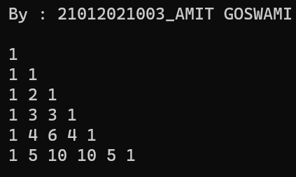

1. **Write a user defined function to sort an array.**

Program:

using System;

using System.Collections.Generic;

using System.Linq;

using System.Text;

using System.Threading.Tasks;

using static System.Net.Mime.MediaTypeNames;

namespace Practical_3

{

internal class Practical_3_4_

{

static void Main(string[] args)

{

Console.WriteLine("By : 21012021003_AMIT GOSWAMI \n");

int n, i;

Console.Write("Please enter size of array : ");

n = Convert.ToInt32(Console.ReadLine());

int[] arr = new int[n];

Console.WriteLine("Enter the values you want to sort in array :");

for (i = 0; i < n; i++)

{

arr[i] = Convert.ToInt32(Console.ReadLine());

}

sort(arr, n);

}

public static void sort(int[] arr, int n)

{

int i, j, temp;

for (i = 0; i <= n - 1; i++)

{

for (j = i + 1; j < n; j++)

{

if (arr[i] > arr[j])

{

temp = arr[i];

arr[i] = arr[j];

arr[j] = temp;

}

}

}

Console.WriteLine("Printing the sorted array :");

for (i = 0; i < n; i++)

{

Console.Write(arr[i] + " ");

}

Console.ReadKey();

}

}

}

Output:

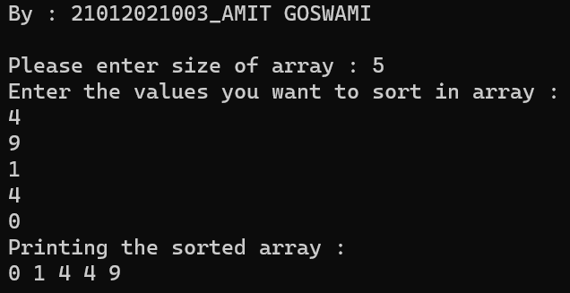

1. **Demonstrate the use of params keyword with the help of a program.**

**Program:**

**using System;**

**using System.Collections.Generic;**

**using System.Linq;**

**using System.Text;**

**using System.Threading.Tasks;**

**using static System.Net.Mime.MediaTypeNames;**

**namespace Practical_3**

**{**

**internal class Practical_3_5_**

**{**

**static void Main(string[] args)**

**{**

**Console.WriteLine("By : 21012021003_AMIT GOSWAMI \n");**

**int m;**

**m = Mul(5, 9, 10, 45, 2, 43);**

**Console.WriteLine("Multiplication of each and every element of array: " + m);**

**Console.ReadKey();**

**}**

**public static int Mul(params int[] arr)**

**{**

**int mul = 1;**

**foreach (int i in arr)**

**{**

**mul = i * mul;**

**}**

**return mul;**

**}**

**}**

**}**

**Output:**

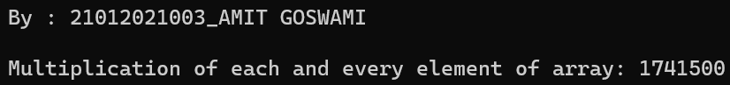

1. **Discuss out and ref parameters with the help of programs.**

**Program:**

using System;

using System.Collections.Generic;

using System.Linq;

using System.Text;

using System.Threading.Tasks;

using static System.Net.Mime.MediaTypeNames;

namespace Practical_3

{

internal class Practical_3_6_

{

static void Main()

{

Console.WriteLine("By :21012021003_AMIT GOSWAMI \n");

int a, b, ans;

Mul(out a, out b, out ans);

Console.WriteLine("multipication of two numbers is " + ans);

}

static void Mul(out int c, out int d, out int ans)

{

c = 23;

d = 12;

ans = c * d;

Console.ReadKey();

}

}

}

**Output:**

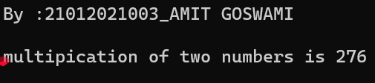

**Program:**

using System;

using System.Collections.Generic;

using System.Linq;

using System.Text;

using System.Threading.Tasks;

using static System.Net.Mime.MediaTypeNames;

namespace Practical_3

{

internal class Practical_3_6

{

static void Main()

{

Console.WriteLine("By : 21012021003_AMIT GOSWAMI \n");

int a = 1, b = 2, ans = 1;

Mul(ref a, ref b, ref ans);

Console.WriteLine("multipication of two numbers is " + ans);

}

static void Mul(ref int c, ref int d, ref int ans)

{

c = 25;

d = 34;

ans = c * d;

Console.ReadKey();

}

}

}

**Output:** 